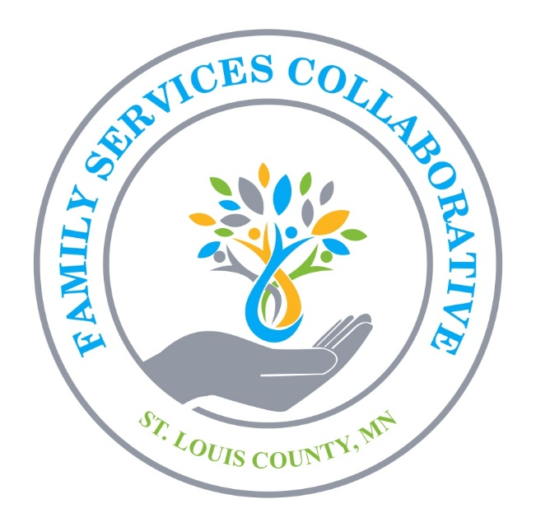

Mission Statement

The St. Louis Family Services Collaborative works to advance an inclusive network of community services that helps families to prevent adverse childhood experiences and develop resiliency, supports healthy child development, and improves educational outcomes.

