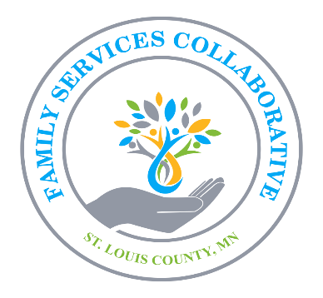 | St. Louis County Family Services Collaborative
Family Services Collaborative of St. Louis County – Grant Evaluation Form
Program Name: _______________________________
Program Lead: _______________________________
Title: _______________________________
Agency: _______________________________
Amount Awarded: _______________________________
Program Dates: _______________________________
Target Population: _______________________________
Number of Persons Served: _______________________________

SECTION 1: PROGRAM SUMMARY
(Provide a brief summary of your program. Include program goals, the population served, how the program addresses community needs, and any evidence-based strategies.)
Program Summary (250 words max):

SECTION 2: PROGRAM NEED / COMMUNITY ALIGNMENT
Collaborative Priority Alignment (select one):
☐ Promote Mental Health & Well-Being of Children, Youth, & Young Adults
☐ Support Healthy Growth & Social Emotional Development
☐ Strengthen Resilience & Protective Factors
Describe how your program aligns with the selected priority and addresses a community need (250 words max):

SECTION 3: PROGRAM OUTCOMES
Instructions:
Report measurable outcomes for your program. Please report on the same outcomes you committed to in your grant application — these are the outcomes the Collaborative will track. Outcomes describe the change or benefit resulting from your program, not just activities, and may involve changes in knowledge, skills, attitudes, behaviors, relationships, access, or conditions. Link each outcome to one Collaborative Priority and include measurable indicators and targets.
Collaborative Priority | Outcome (What change will happen?) | Measure (How will you know?) | Target (Expected change) | Result / Notes for this Outcome
Example: Promote Mental Health | 80% of youth report reduced isolation | Pre/post survey (PHQ-9) | 80% or more show improvement
Program Lessons Learned (200-word max)
Instruction: Provide a brief summary of lessons learned across the program, including what worked well, challenges, and any adjustments made.

SECTION 4: PROGRAM INFORMATION
Program Story & Visuals:
(Include a photo, image, or document (JPEG, PDF, MBP, etc.) that illustrates your program. You may also share a brief story about your program, its impact, or the people it serves.)

SECTION 5: BUDGET SUMMARY
(List expenditures that directly serve children, caregivers, or community well-being. Indirect, administrative, or capital costs are not permitted. Include other funding sources if applicable.)
Item Description | Amount ($)
Staff Salaries & Benefits (include roles, % time, fringe, and total requested; must work directly with children & families)
General Supplies
Beverages & Food
Other
Subtotal
Grand Total

Other Program Funding Sources (if applicable):
Funding Source | Amount | Notes
Total

SECTION 6: COLLABORATION
List all partners, schools, agencies, or organizations involved in this program:

SECTION 7: MEDIA RELEASE
My agency hereby grants the Family Services Collaborative of St. Louis County, MN permission to use the statements, photographs, and/or videos provided. These may be used in any publications or media, whether now known or created in the future.
My agency will make no monetary or other claim against the Family Services Collaborative for the use of these statements, photographs, and/or videos.
Signature: _______________________________
Print Name / Title / Agency: _______________________________

Tips for Completing the Form
- Focus on clear, measurable outcomes linked to a Collaborative Priority.
- Include any lessons learned or adjustments made during the program.
- Ensure photos or visuals illustrate program impact or community engagement.
- Keep explanations concise and include specific data wherever possible.
- Complete all sections; partial forms may affect review.

